Endpoint Intersection

Definition
# Source: AI Source: Provided by: [Data Path: Persons Table -> ID Column: 1, Name_En Column: Motasem Essam] -> From: [ChatGPT] on [7/25/2026]
Endpoint Intersection is a type of Segment Intersection that occurs when two line segments share a common endpoint.
If segments $\overline{AB}$ and $\overline{BC}$ meet at $B$, then:
$$\boxed{\overline{AB}∩\overline{BC}=\{B\}}$$
Here, $B$ is an endpoint of both segments.
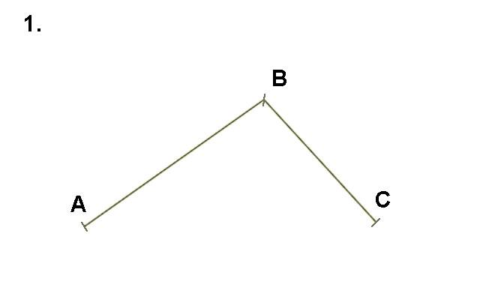
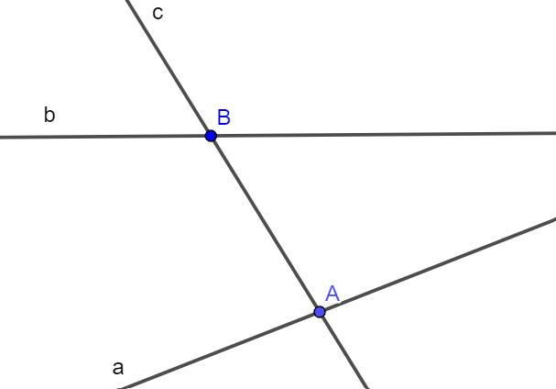

Purpose
# Source: AI Source: Provided by: [Data Path: Persons Table -> ID Column: 1, Name_En Column: Motasem Essam] -> From: [ChatGPT] on [7/25/2026]
Endpoint intersection is used to:
- Identify where line segments meet at their endpoints.
- Define vertices of polygons.
- Connect consecutive segments.
- Construct geometric figures.
- Analyze polygon boundaries.
- Determine connectivity between segments.
- Model paths, networks, and structures.
- Support CAD, GIS, engineering, and computer graphics.

Fundamental Idea
# Source: AI Source: Provided by: [Data Path: Persons Table -> ID Column: 1, Name_En Column: Motasem Essam] -> From: [ChatGPT] on [7/25/2026]
A line segment has two endpoints.
For example:
$$\overline{AB}$$
has endpoints:
$$A,B$$
and:
$$\overline{BC}$$
has endpoints:
$$B,C$$
The two segments share $B$:
$$\boxed{\overline{AB}∩\overline{BC}=\{B\}}$$
Therefore, (B) is an endpoint intersection.

Mathematical Representation
# Source: AI Source: Provided by: [Data Path: Persons Table -> ID Column: 1, Name_En Column: Motasem Essam] -> From: [ChatGPT] on [7/25/2026]
If two segments share an endpoint $P$:
$$\boxed{\overline{AB}∩\overline{PC}=\{P\}}$$
where $P$ is an endpoint of both segments.
More generally:
$$\boxed{\overline{AB}∩\overline{CD}=\{P\}}$$
and:
$$\boxed{P∈\{A,B\}∩\{C,D\}}$$
This means that $P$ must be an endpoint of both segments.

Simple Example
# Source: AI Source: Provided by: [Data Path: Persons Table -> ID Column: 1, Name_En Column: Motasem Essam] -> From: [ChatGPT] on [7/25/2026]
Consider:
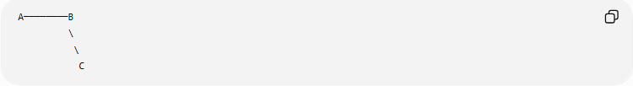
A────────B
\
\
C
The segments are:
$$\overline{AB}$$
and:
$$\overline{BC}$$
They meet at:
$$\boxed{B}$$
Therefore:
$$\boxed{\overline{AB}∩\overline{BC}=\{B\}}$$
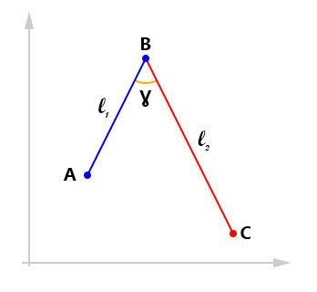
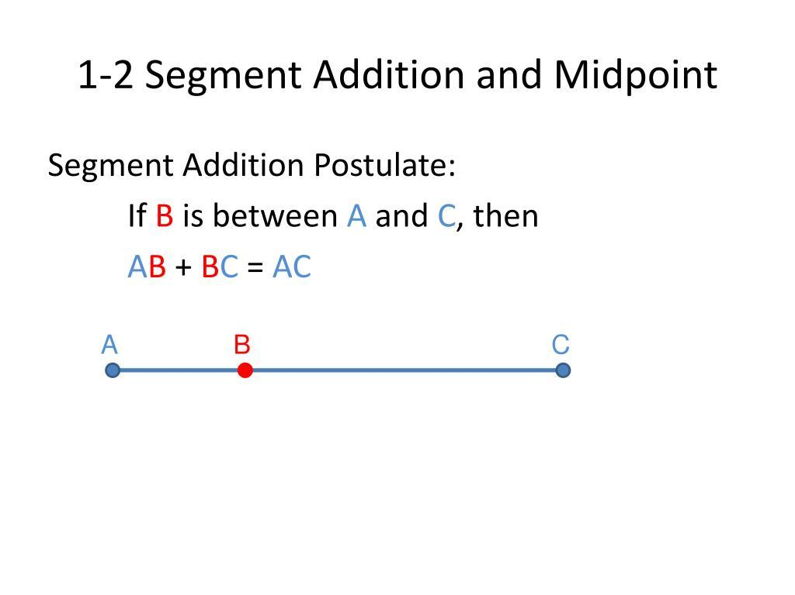
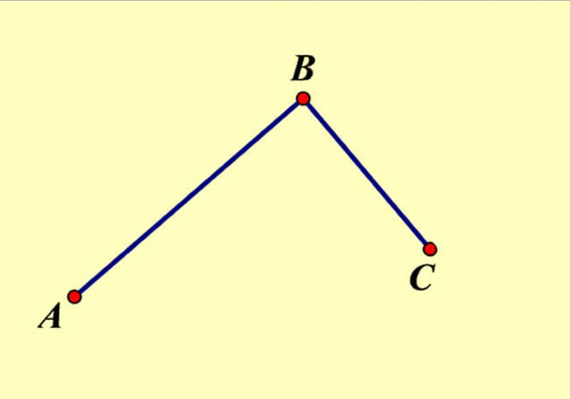

Endpoint Intersection in a Polygon
# Source: AI Source: Provided by: [Data Path: Persons Table -> ID Column: 1, Name_En Column: Motasem Essam] -> From: [ChatGPT] on [7/25/2026]
Endpoint intersections are fundamental to polygons.
For a triangle $ABC$:
$$\overline{AB}∩\overline{BC}=\{B\} \\ \overline{BC}∩\overline{CA}=\{C\} \\ \overline{CA}∩\overline{AB}=\{A\}$$
The shared endpoints form the vertices of the triangle.
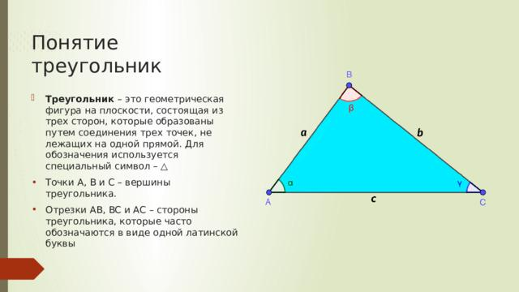
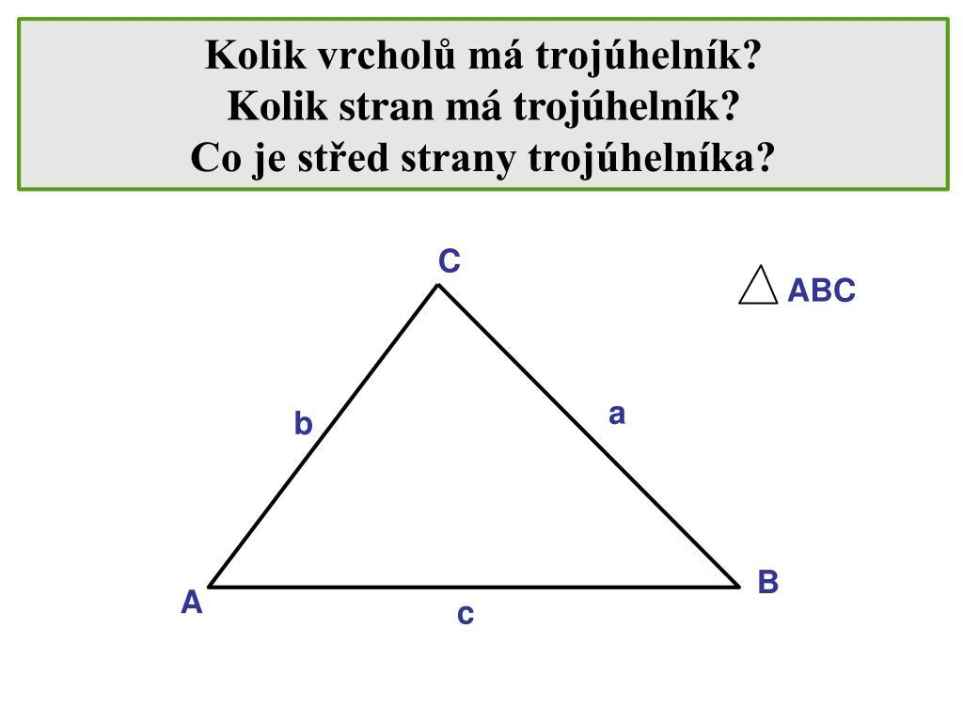
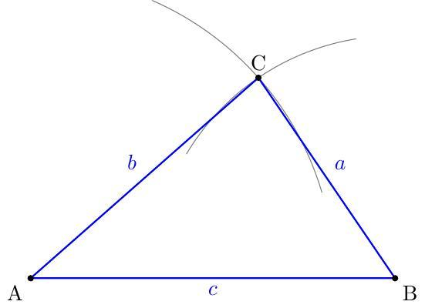

Endpoint Intersections in a Quadrilateral
# Source: AI Source: Provided by: [Data Path: Persons Table -> ID Column: 1, Name_En Column: Motasem Essam] -> From: [ChatGPT] on [7/25/2026]
Consider quadrilateral $ABCD$.
Its sides are:
$$\overline{AB}, \overline{BC}, \overline{CD}, \overline{DA}$$
Adjacent sides meet at endpoints:
$$\boxed{\overline{AB}∩\overline{BC}=\{B\}} \\ \boxed{\overline{BC}∩\overline{CD}=\{C\}} \\ \boxed{\overline{CD}∩\overline{DA}=\{D\}} \\ \boxed{\overline{DA}∩\overline{AB}=\{A\}}$$
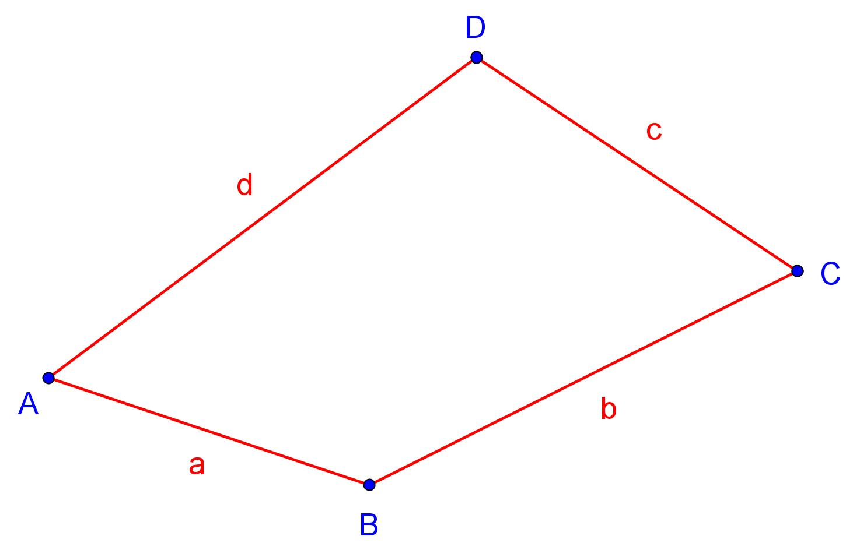
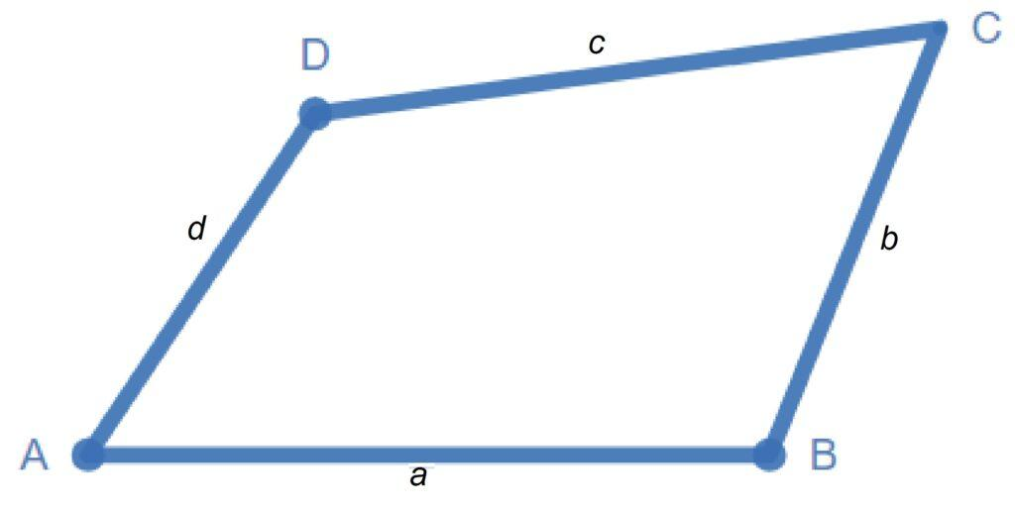
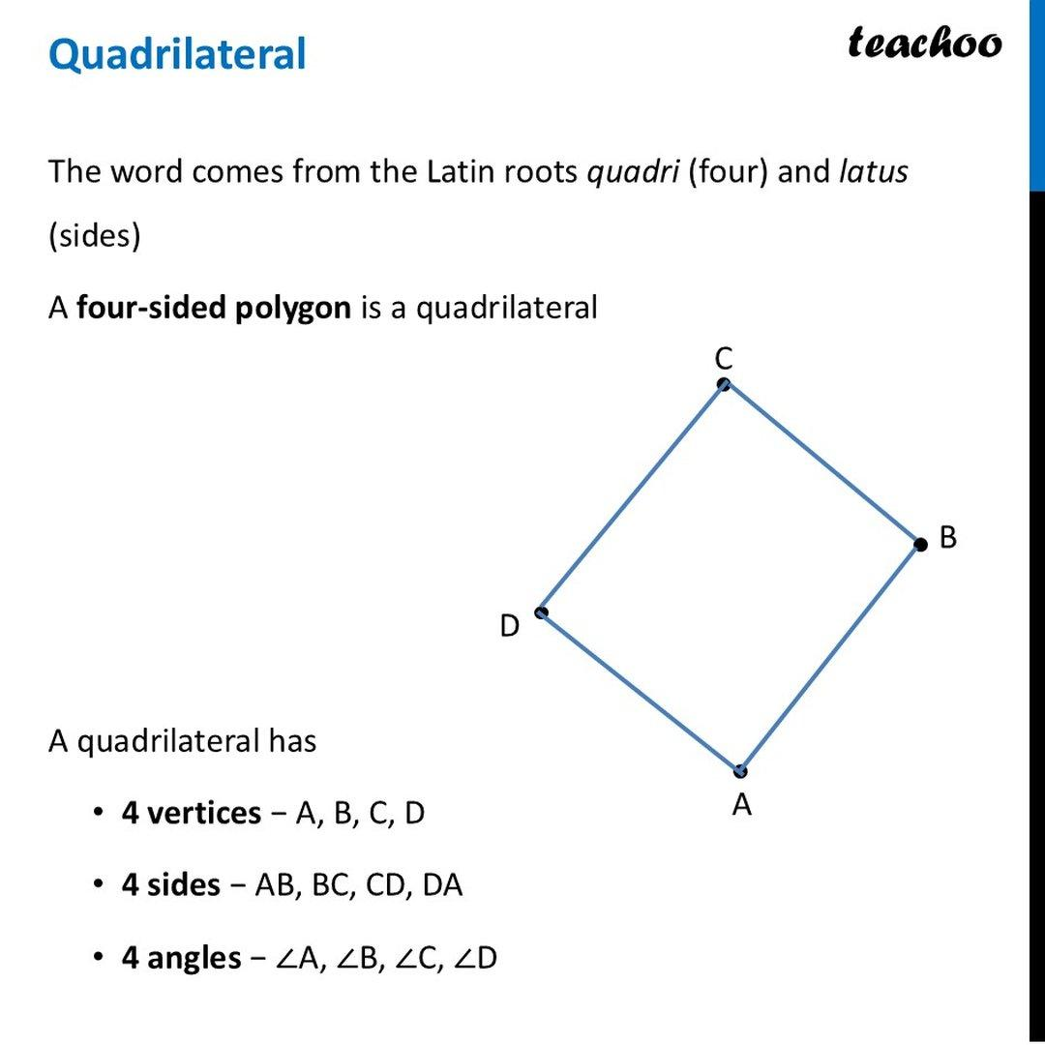

Endpoint Intersection vs. Interior Intersection
# Source: AI Source: Provided by: [Data Path: Persons Table -> ID Column: 1, Name_En Column: Motasem Essam] -> From: [ChatGPT] on [7/25/2026]
These are two different types of segment intersection.
Endpoint Intersection
The common point is an endpoint:
$$\boxed{\overline{AB}∩\overline{CD}=\{P\}}$$
where $P$ is an endpoint of both segments.
Interior Intersection
The common point lies strictly inside both segments:
$$\boxed{A-P-B}$$
and:
$$\boxed{C-P-D}$$
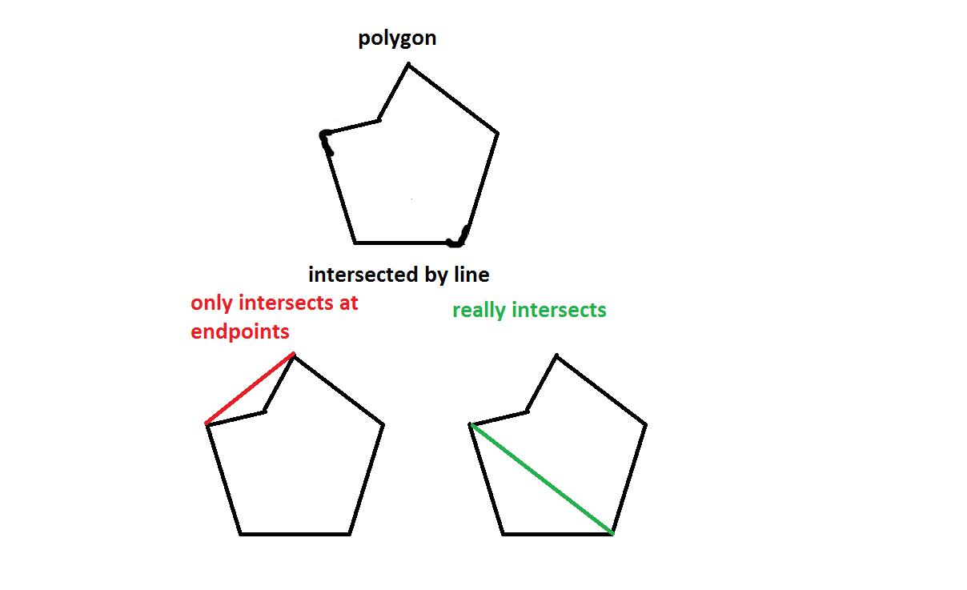
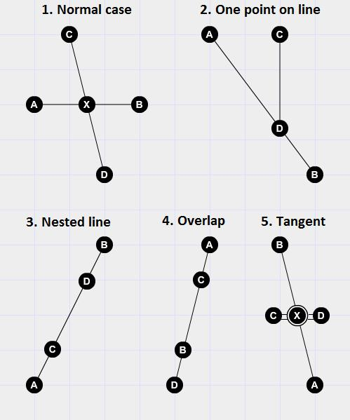
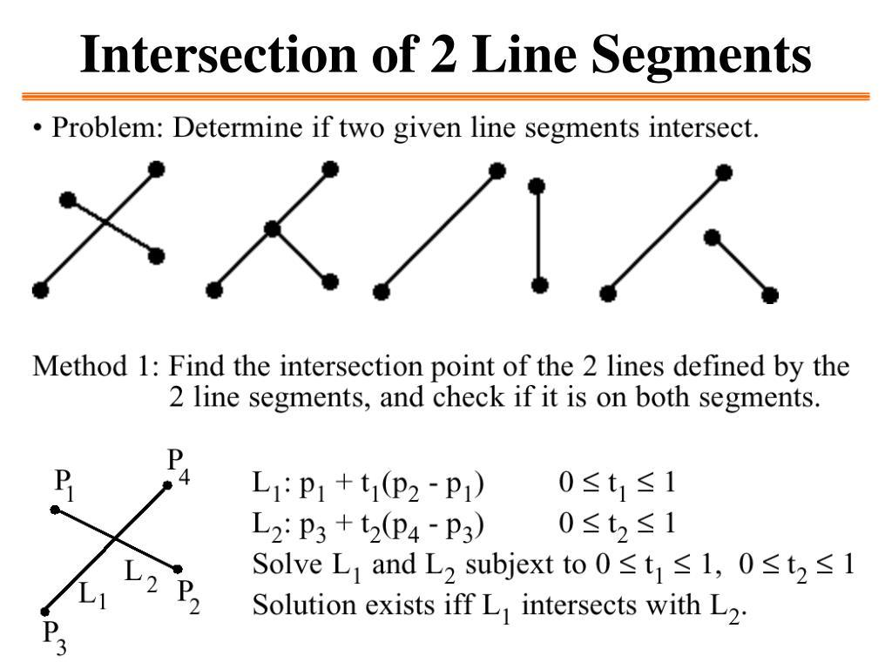

Endpoint Intersection vs. Overlapping Intersection
# Source: AI Source: Provided by: [Data Path: Persons Table -> ID Column: 1, Name_En Column: Motasem Essam] -> From: [ChatGPT] on [7/25/2026]
Two collinear segments can also share an endpoint.
For example:
A────────B
────────C
If $B=C$, then the segments meet at exactly one endpoint.
However, if they extend over the same portion, the intersection becomes an overlapping intersection.
For example:
$$\boxed{\overline{AB}∩\overline{CD}=\overline{PQ}}$$
contains infinitely many points.
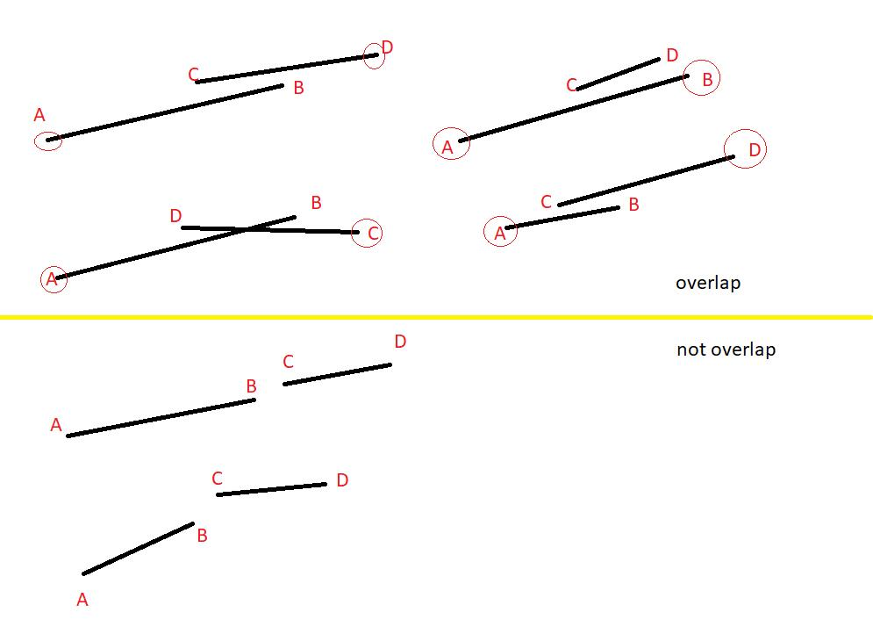
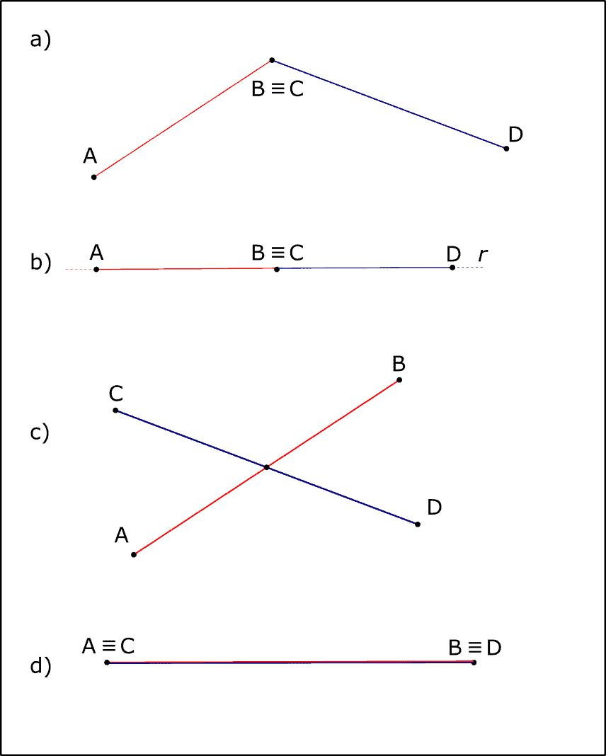

Endpoint Intersection and Vertices
# Source: AI Source: Provided by: [Data Path: Persons Table -> ID Column: 1, Name_En Column: Motasem Essam] -> From: [ChatGPT] on [7/25/2026]
A vertex is commonly formed where two or more segments meet.
For example:
$$\overline{AB}$$
and:
$$\overline{BC}$$
meet at:
$$B$$
Therefore, $B$ is a vertex.
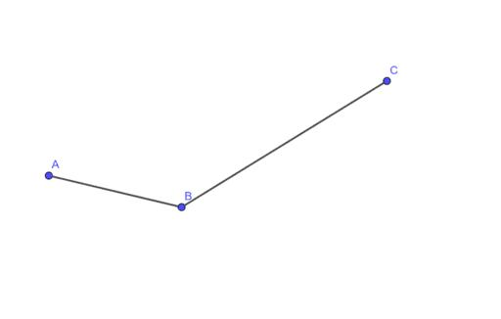
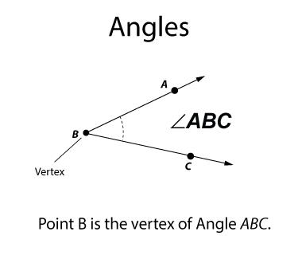
This is why endpoint intersections are fundamental to polygon construction.

Multiple Segments Sharing One Endpoint
# Source: AI Source: Provided by: [Data Path: Persons Table -> ID Column: 1, Name_En Column: Motasem Essam] -> From: [ChatGPT] on [7/25/2026]
More than two segments can share the same endpoint.
For example:
$$\overline{PA}, \overline{PB}, \overline{PC}$$
all share $P$.
Thus:
$$\boxed{P∈\overline{PA}∩\overline{PB}∩\overline{PC}}$$
This is a common endpoint of multiple segments.
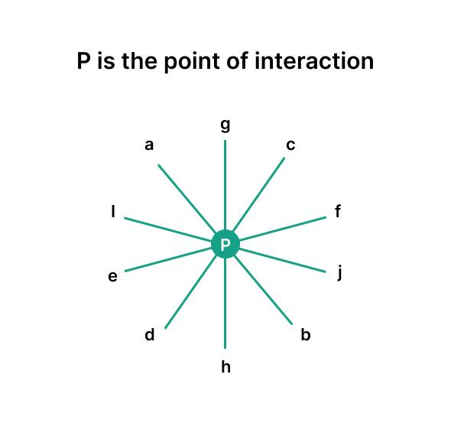
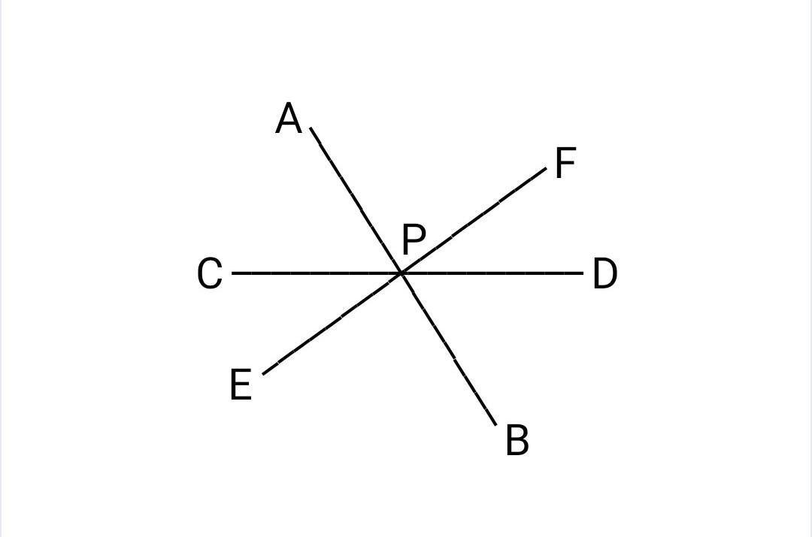
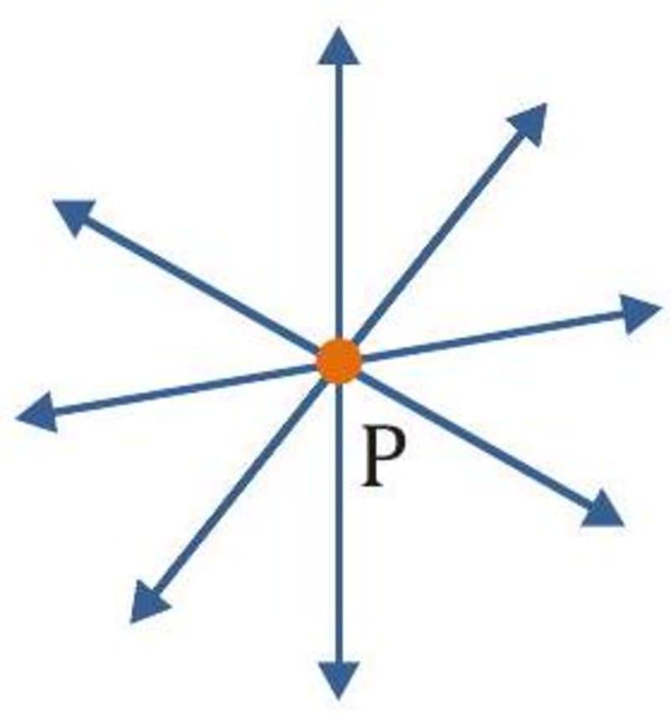
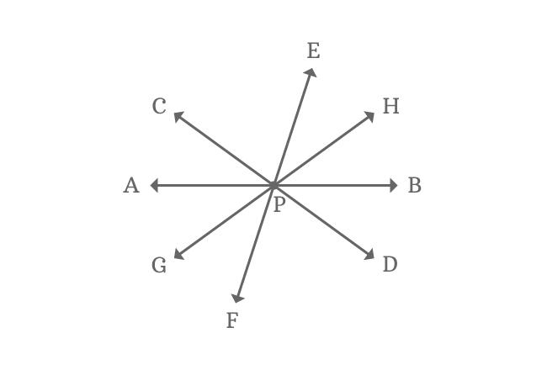

Endpoint Intersection and Angles
# Source: AI Source: Provided by: [Data Path: Persons Table -> ID Column: 1, Name_En Column: Motasem Essam] -> From: [ChatGPT] on [7/25/2026]
When two segments share an endpoint, they can form an angle.
For example:
$$\overline{AB}$$
and:
$$\overline{BC}$$
share endpoint $B$.
The angle formed is:
$$\boxed{∠ABC}$$
Here, (B) is the vertex of the angle.
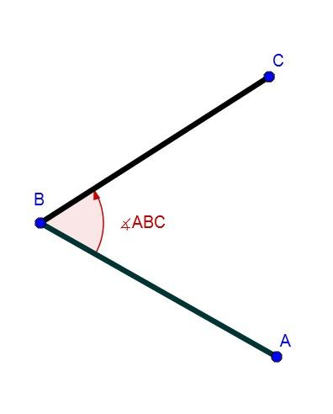
The size of the angle depends on the directions of the two segments.

Endpoint Intersection and Polygon Boundaries
# Source: AI Source: Provided by: [Data Path: Persons Table -> ID Column: 1, Name_En Column: Motasem Essam] -> From: [ChatGPT] on [7/25/2026]
A polygon is made from connected line segments.
For example:
$$A→B→C→D→A$$
Each consecutive pair of segments shares an endpoint.
Thus:
$$\overline{AB}∩\overline{BC}=B$$
and:
$$\overline{BC}∩\overline{CD}=C$$
and so on.
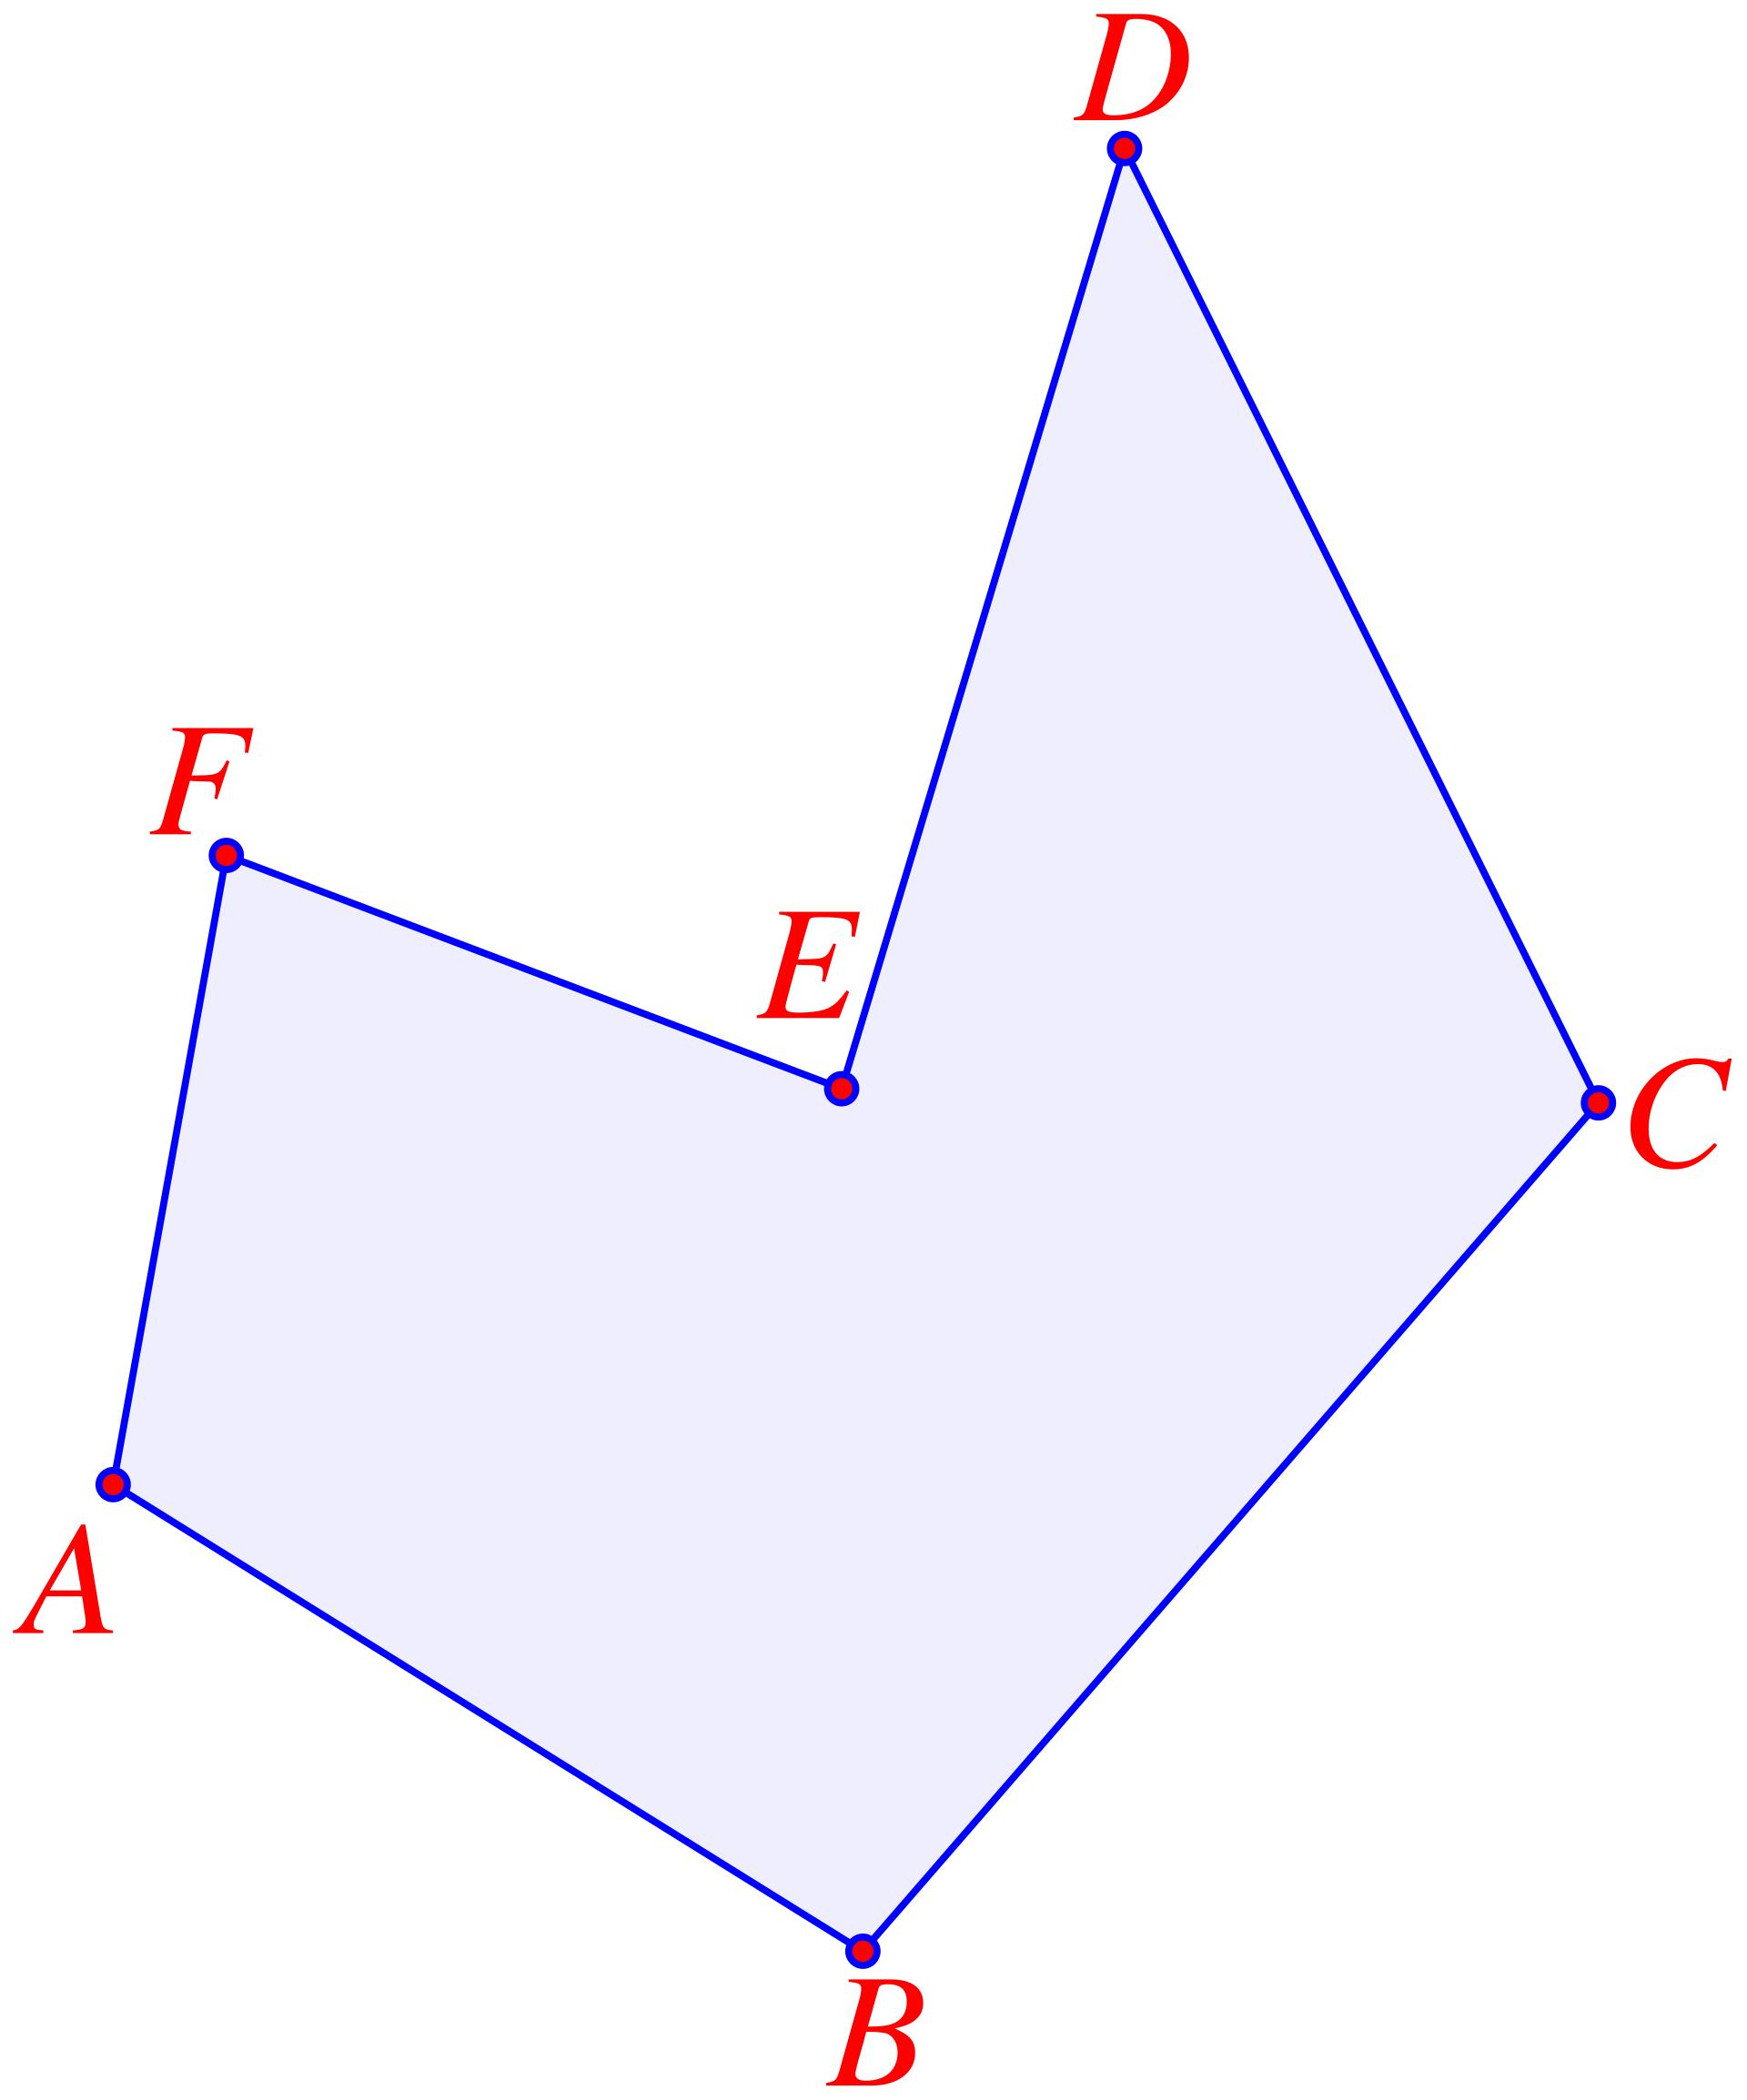
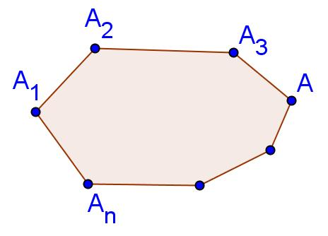
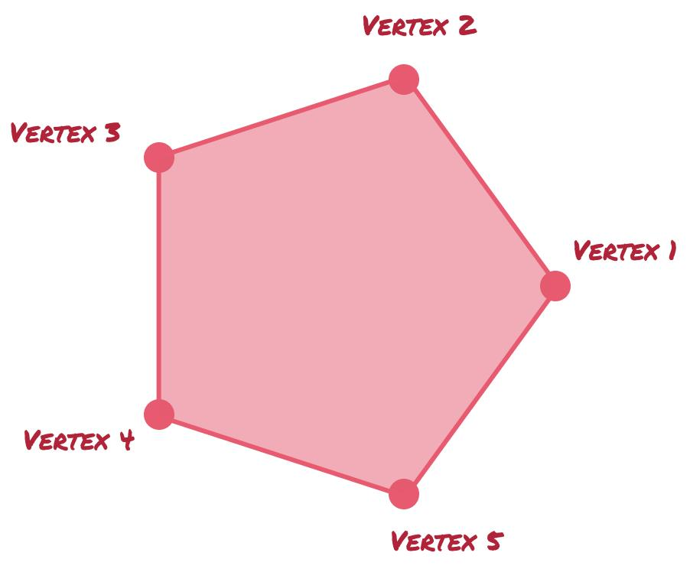
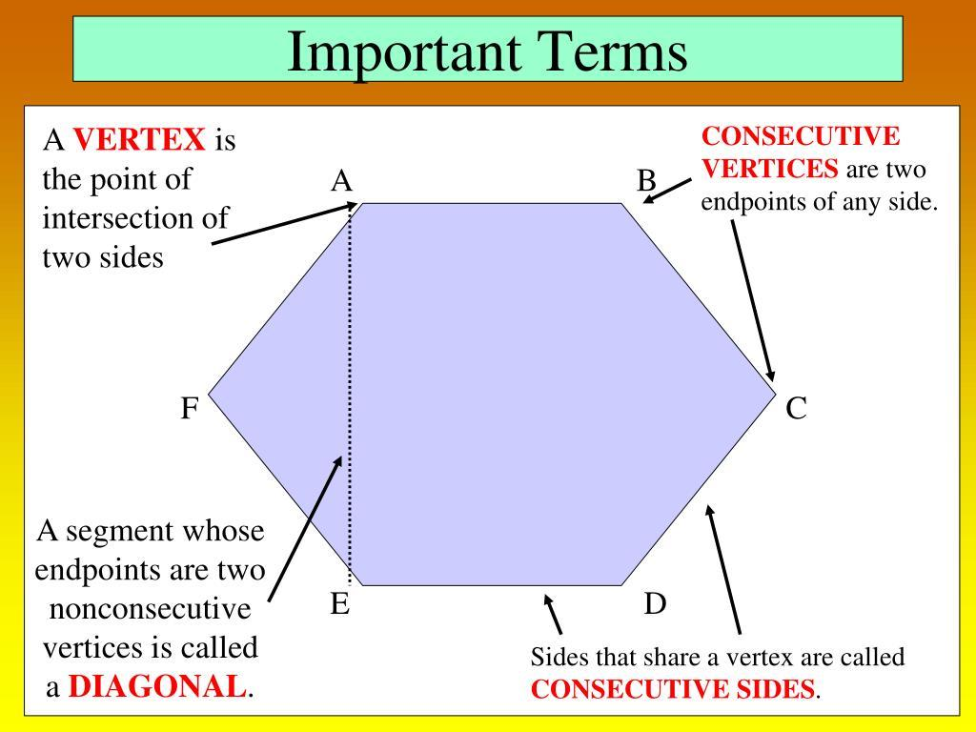

Endpoint Intersection in a Polyline
# Source: AI Source: Provided by: [Data Path: Persons Table -> ID Column: 1, Name_En Column: Motasem Essam] -> From: [ChatGPT] on [7/25/2026]
An open polyline is formed by connecting segments end to end.
For example:
$$A→B→C→D$$
The intersections are:
$$\boxed{\overline{AB}∩\overline{BC}=\{B\}}$$
and:
$$\boxed{\overline{BC}∩\overline{CD}=\{C\}}$$
These are endpoint intersections.
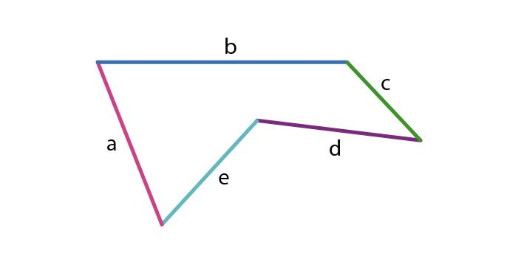
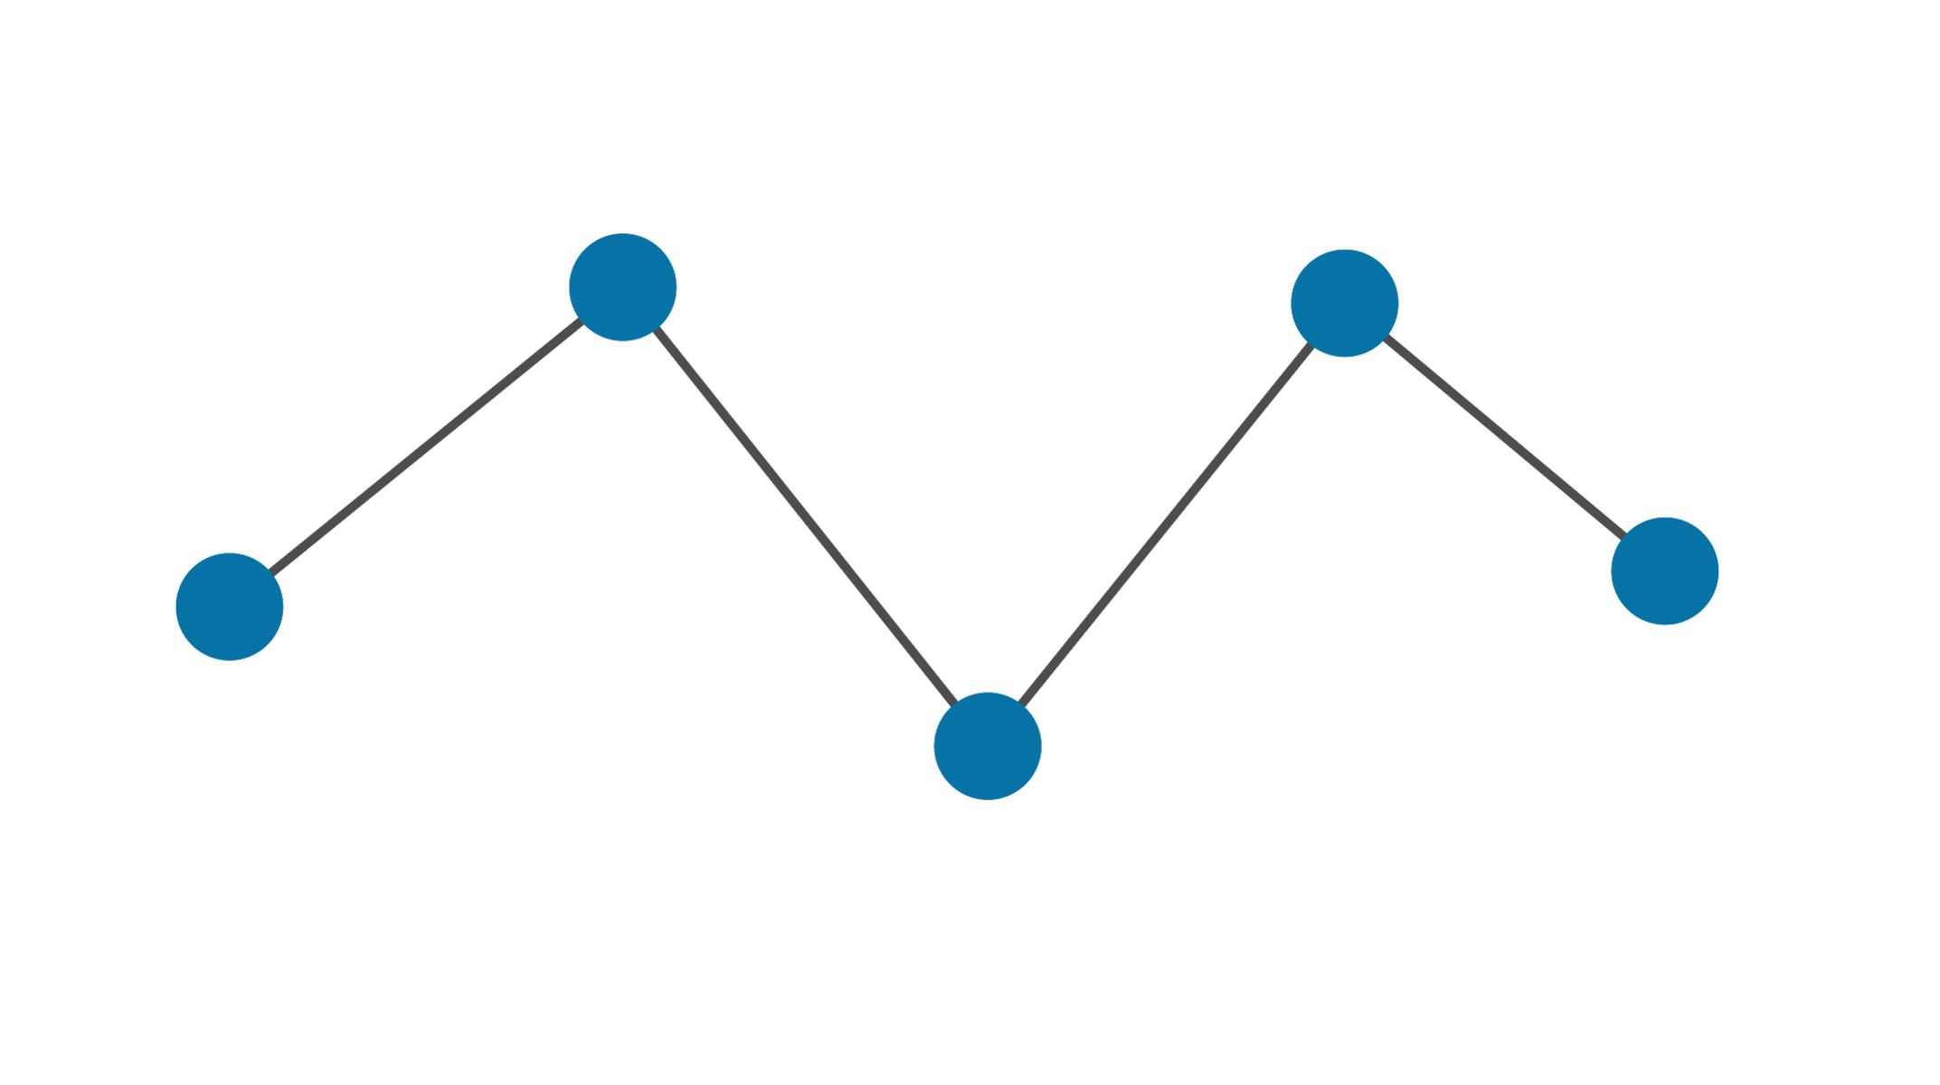
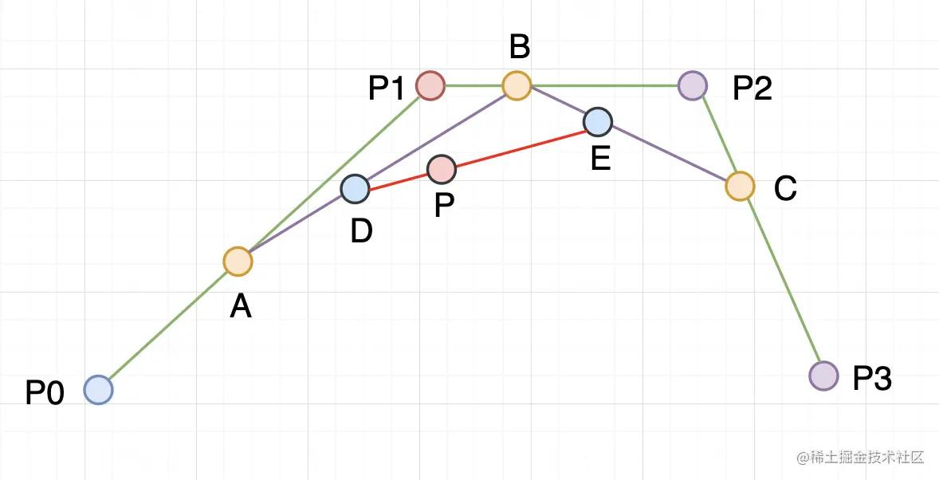

Endpoint Intersection in a Closed Polyline
# Source: AI Source: Provided by: [Data Path: Persons Table -> ID Column: 1, Name_En Column: Motasem Essam] -> From: [ChatGPT] on [7/25/2026]
In a closed polyline, the final segment connects back to the starting point.
For example:
$$A→B→C→D→A$$
The first and last segments also share an endpoint:
$$\boxed{\overline{DA}∩\overline{AB}=\{A\}}$$
This creates a closed boundary.
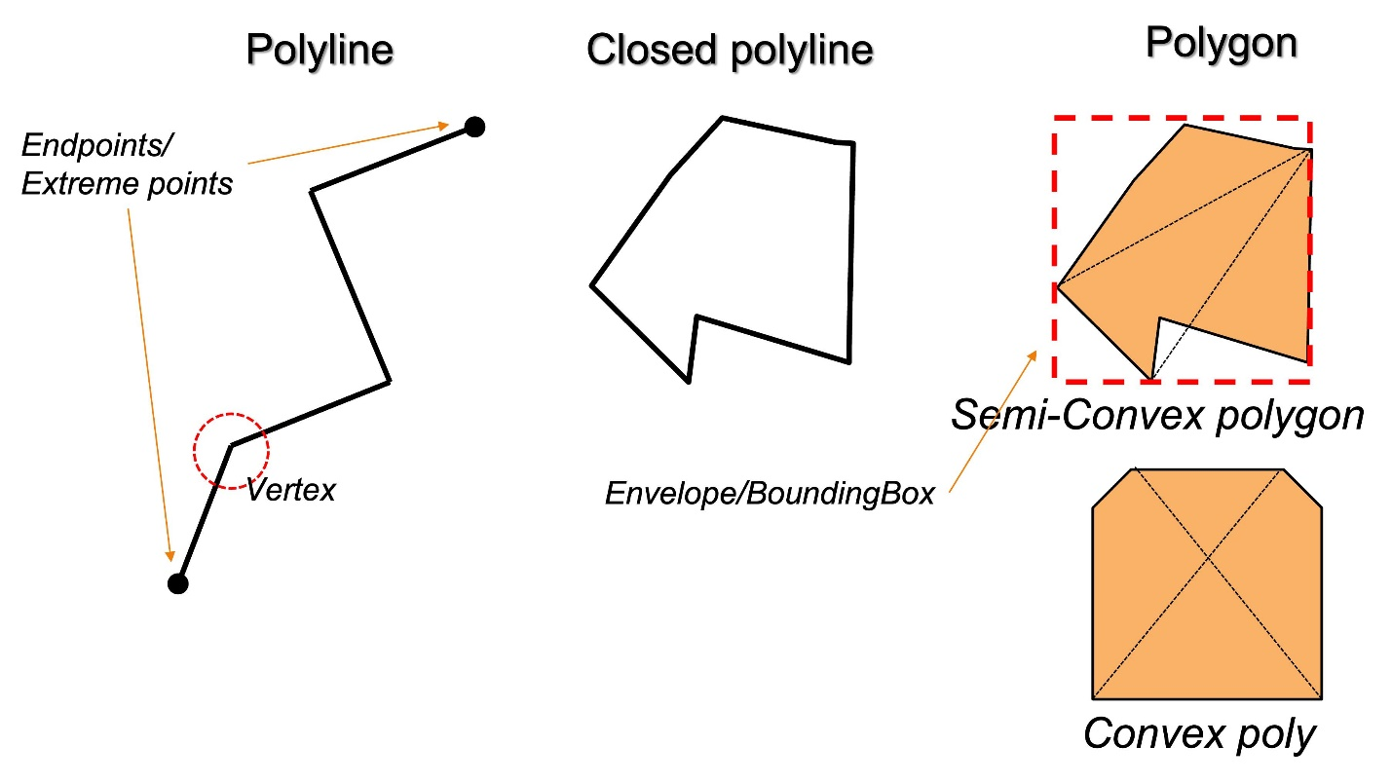
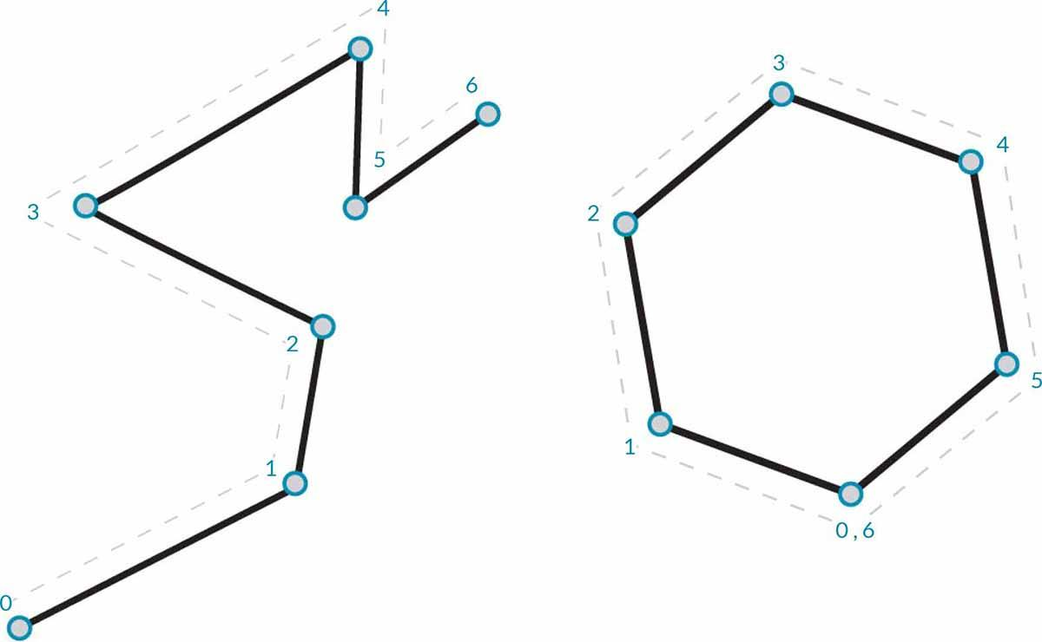
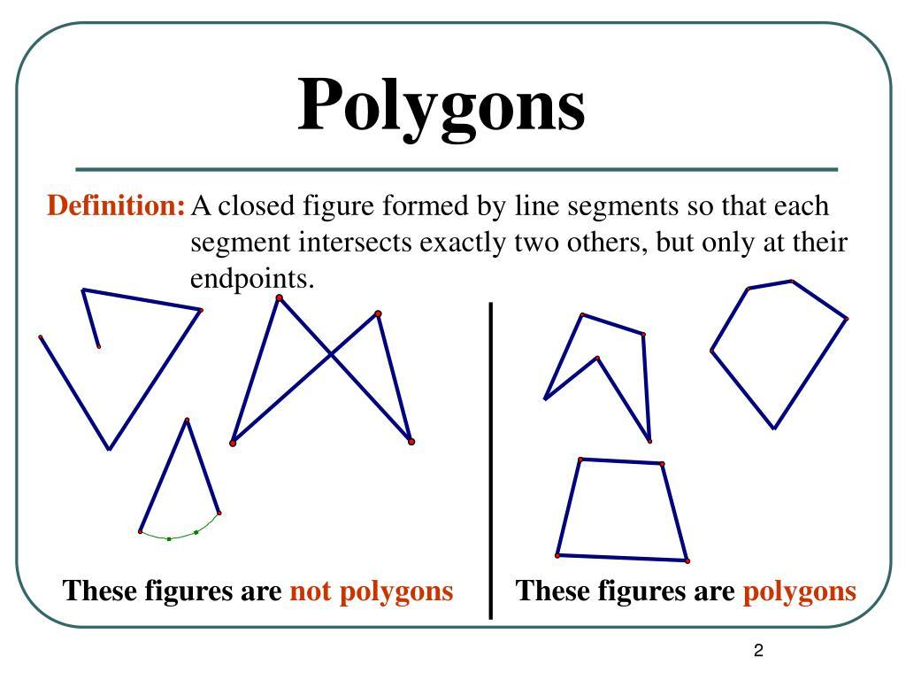
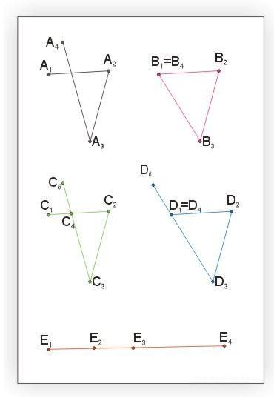
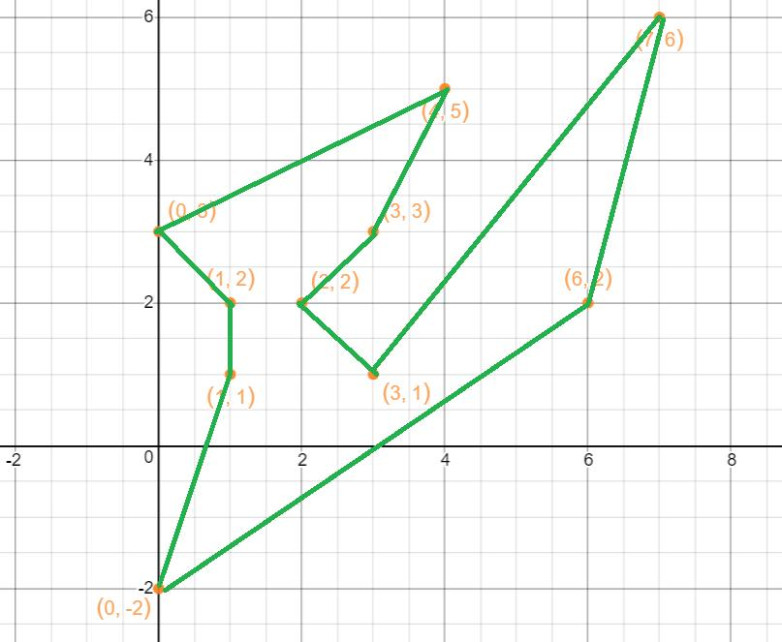

Endpoint Intersection in Coordinate Geometry
# Source: AI Source: Provided by: [Data Path: Persons Table -> ID Column: 1, Name_En Column: Motasem Essam] -> From: [ChatGPT] on [7/25/2026]
Suppose:
$$A=\left(1,2\right) \\ B=\left(4,5\right)$$
and:
$$C=\left(7,1\right)$$
The segments:
$$\overline{AB}$$
and:
$$\overline{BC}$$
share endpoint:
$$\boxed{B=\left(4,5\right)}$$
Therefore:
$$\boxed{\overline{AB}∩\overline{BC}=\{\left(4,5\right)\}}$$
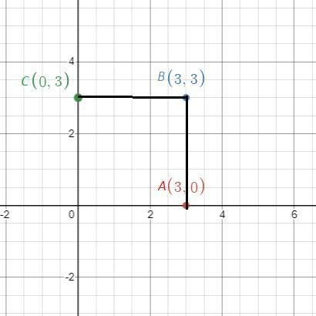
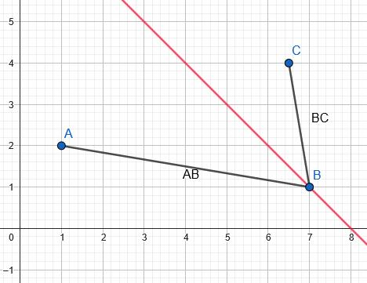
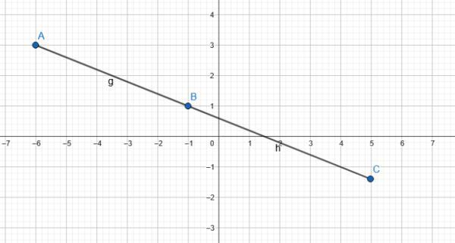

Endpoint Intersection and Perpendicularity
# Source: AI Source: Provided by: [Data Path: Persons Table -> ID Column: 1, Name_En Column: Motasem Essam] -> From: [ChatGPT] on [7/25/2026]
Two segments can meet at an endpoint and still be perpendicular.
For example:
$$\overline{AB}⊥\overline{BC}$$
with common endpoint $B$.
Then:
$$\boxed{∠ABC={90}^{∘}}$$
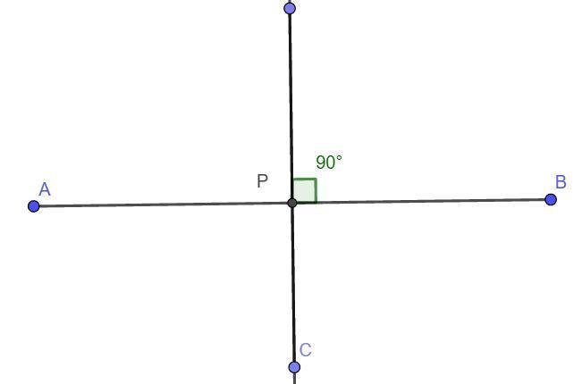
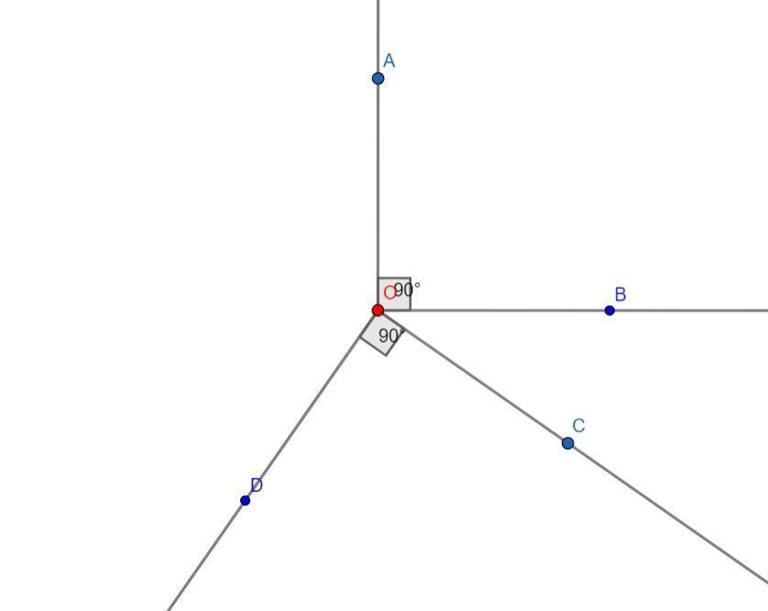
A square provides many examples of perpendicular endpoint intersections.

Endpoint Intersection and Parallelism
# Source: AI Source: Provided by: [Data Path: Persons Table -> ID Column: 1, Name_En Column: Motasem Essam] -> From: [ChatGPT] on [7/25/2026]
Two segments that share an endpoint cannot be distinct parallel segments in the usual Euclidean sense.
For example, if:
$$\overline{AB}$$
and:
$$\overline{BC}$$
share $B$, they meet at $B$, so they are not parallel.
Thus:
$$\boxed{\text{Shared endpoint}⇒\text{intersection}}$$
for distinct segments.

Endpoint Intersection in CAD
# Source: AI Source: Provided by: [Data Path: Persons Table -> ID Column: 1, Name_En Column: Motasem Essam] -> From: [ChatGPT] on [7/25/2026]
CAD systems use endpoint intersections constantly.
For example, two lines may be joined by connecting:
$$B$$
to:
$$B$$
This creates a connected geometric structure.
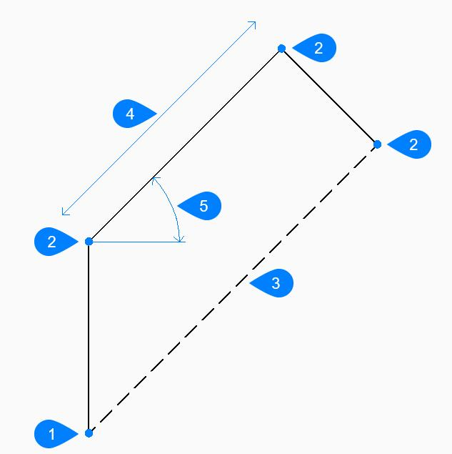
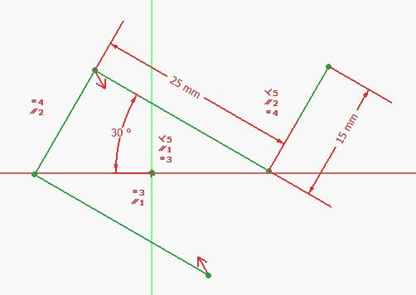
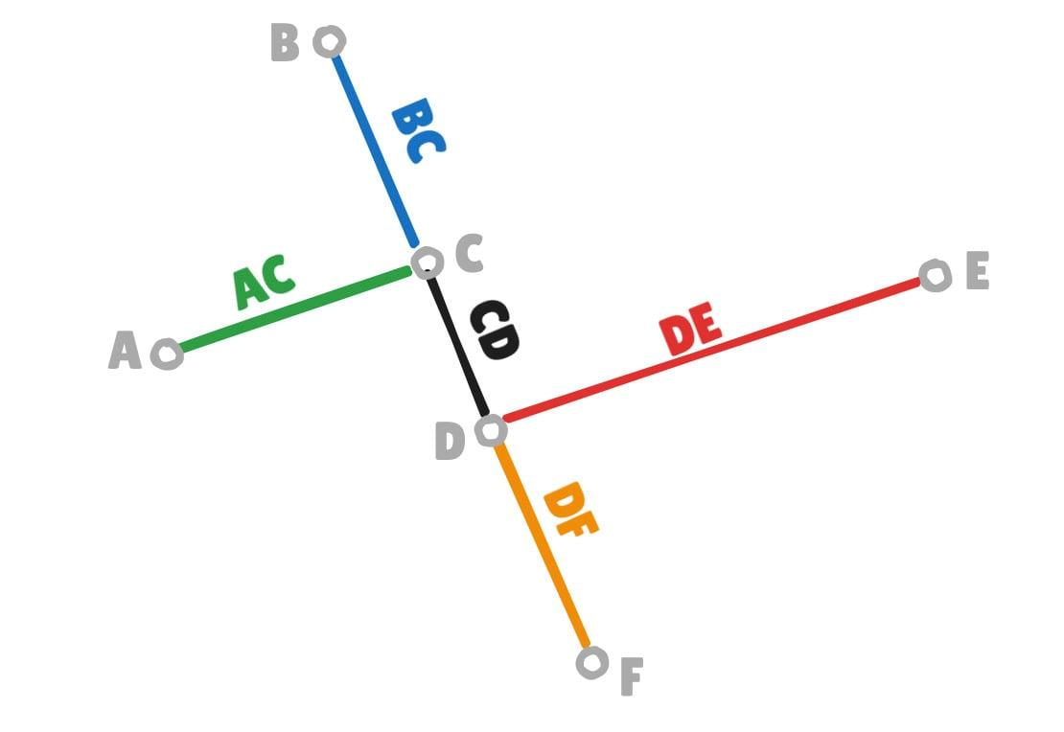
Endpoint relationships are important for:
- Creating polygons.
- Joining paths.
- Creating boundaries.
- Building technical drawings.
- Connecting structural elements.

Endpoint Intersection in Architecture
# Source: AI Source: Provided by: [Data Path: Persons Table -> ID Column: 1, Name_En Column: Motasem Essam] -> From: [ChatGPT] on [7/25/2026]
Architectural drawings contain many endpoint intersections.
Examples include:
- Walls meeting at corners.
- Beams meeting at joints.
- Floor boundaries meeting at vertices.
- Roof edges meeting at corners.
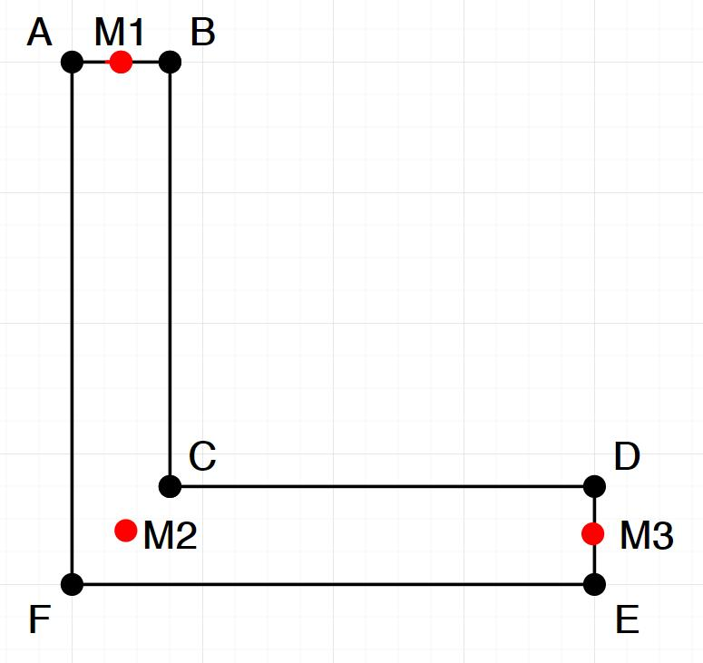
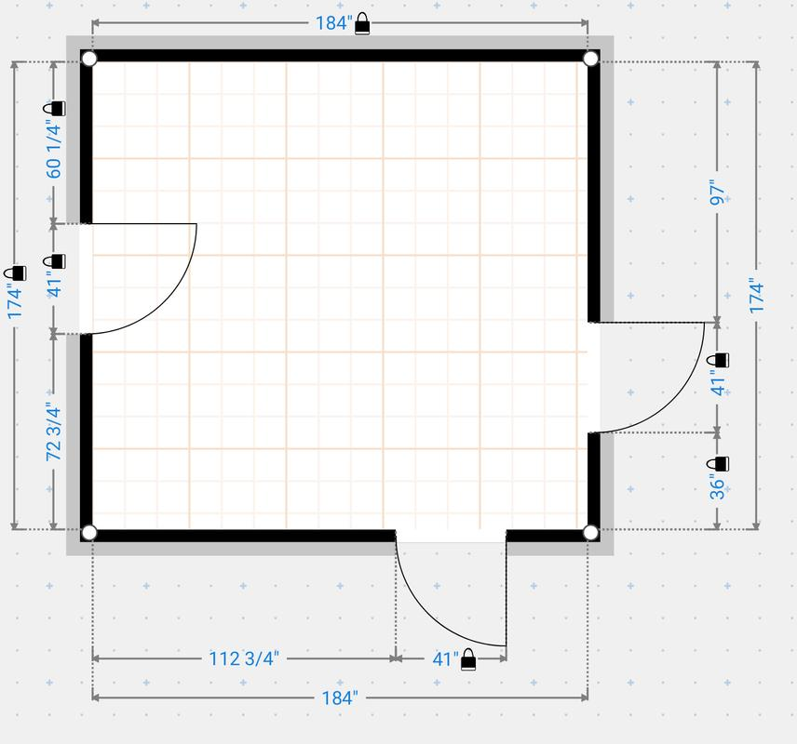
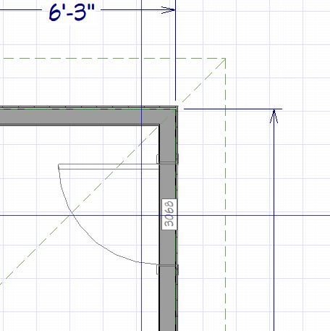
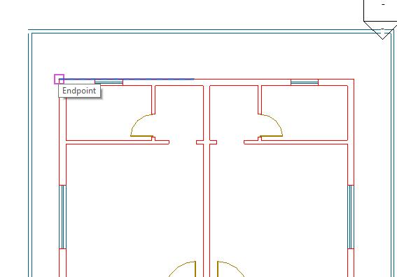
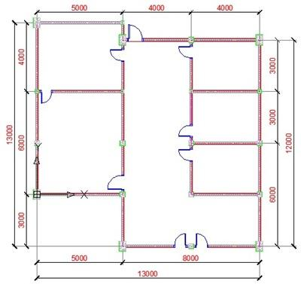

Endpoint Intersection in Engineering
# Source: AI Source: Provided by: [Data Path: Persons Table -> ID Column: 1, Name_En Column: Motasem Essam] -> From: [ChatGPT] on [7/25/2026]
Engineering structures frequently contain connected segments.
For example, a truss is constructed from members that meet at joints.
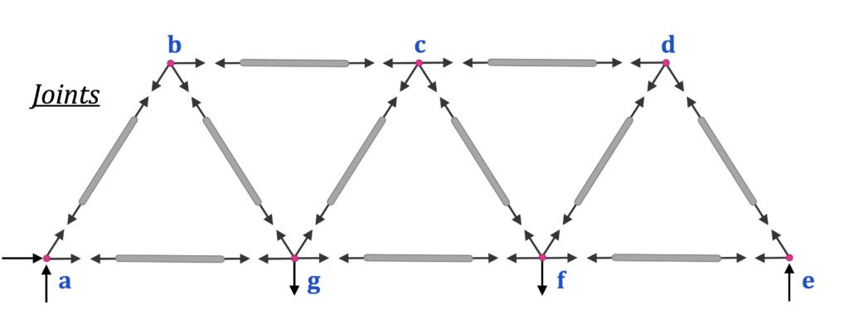
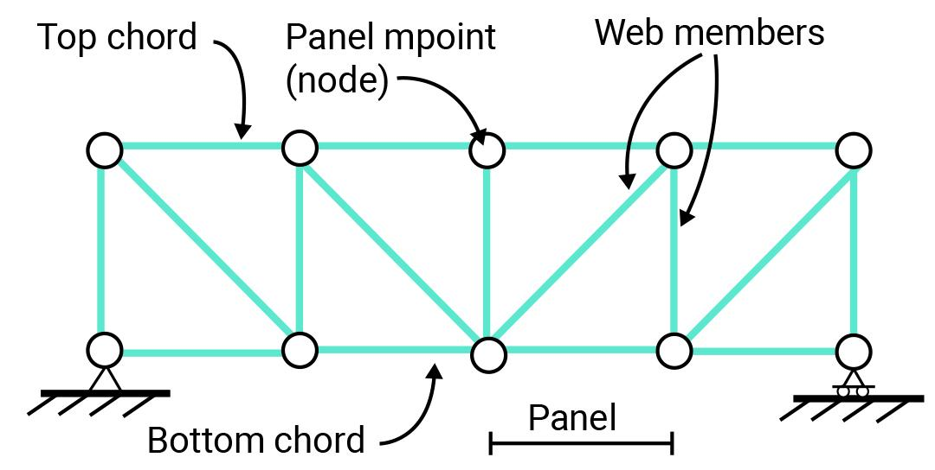
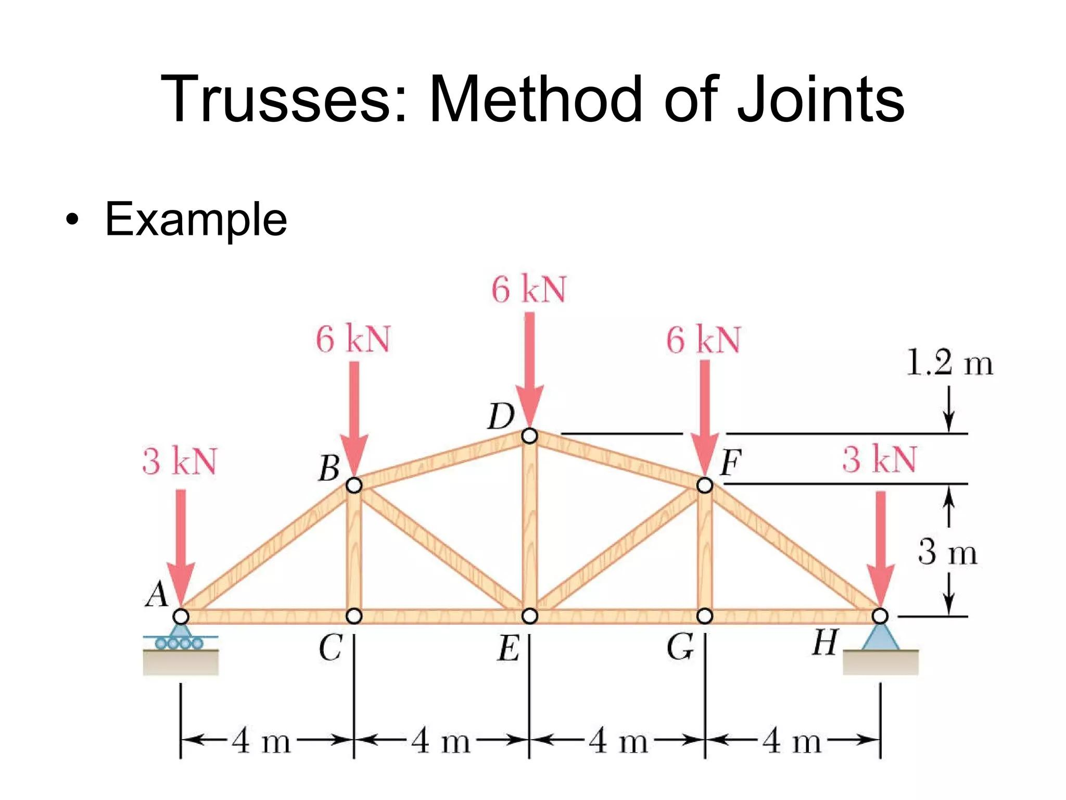
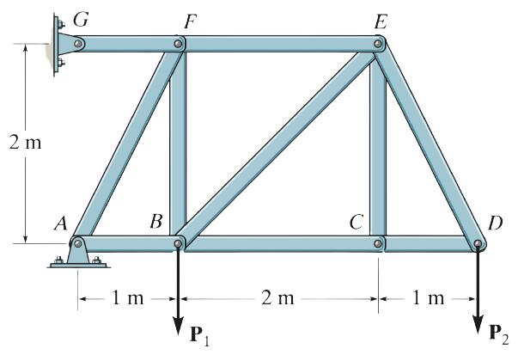
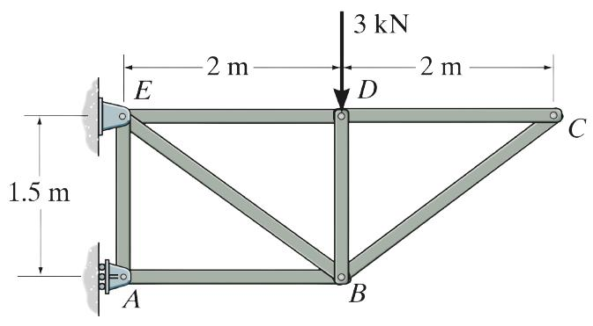
The connection points can be modeled as endpoint intersections.

Endpoint Intersection in GIS and Mapping
# Source: AI Source: Provided by: [Data Path: Persons Table -> ID Column: 1, Name_En Column: Motasem Essam] -> From: [ChatGPT] on [7/25/2026]
Maps use connected line segments to represent:
- Roads.
- Railway networks.
- Rivers.
- Trails.
- Boundaries.
For example, two road segments can meet at a junction represented by a shared endpoint.
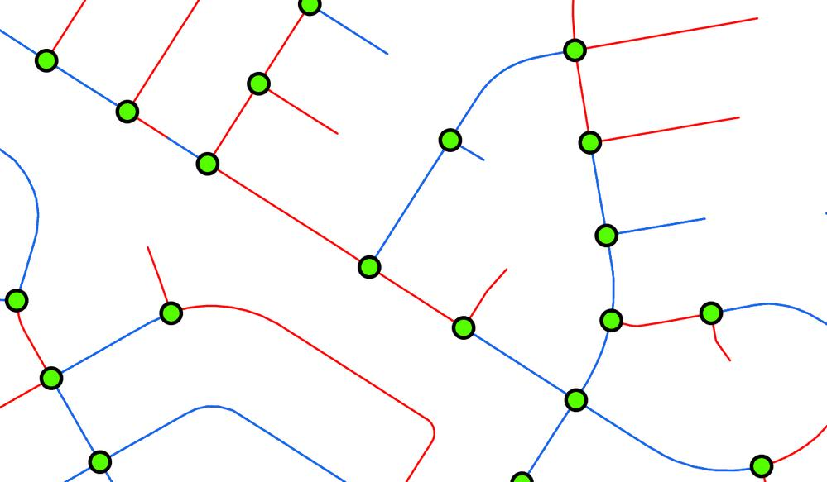
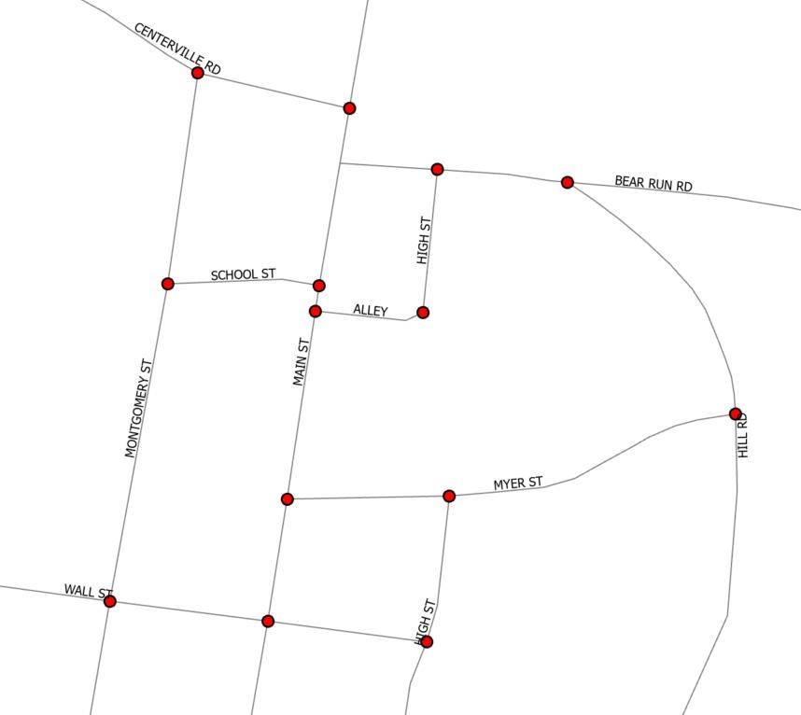
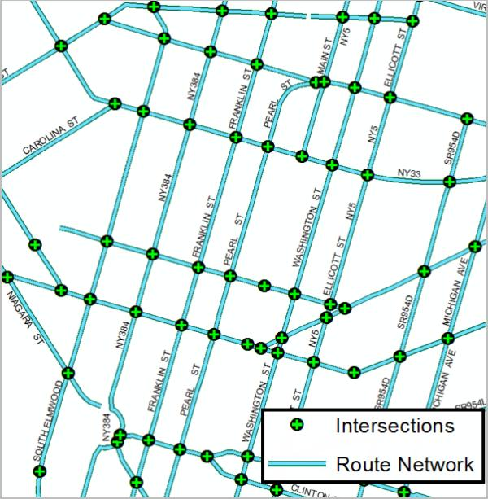
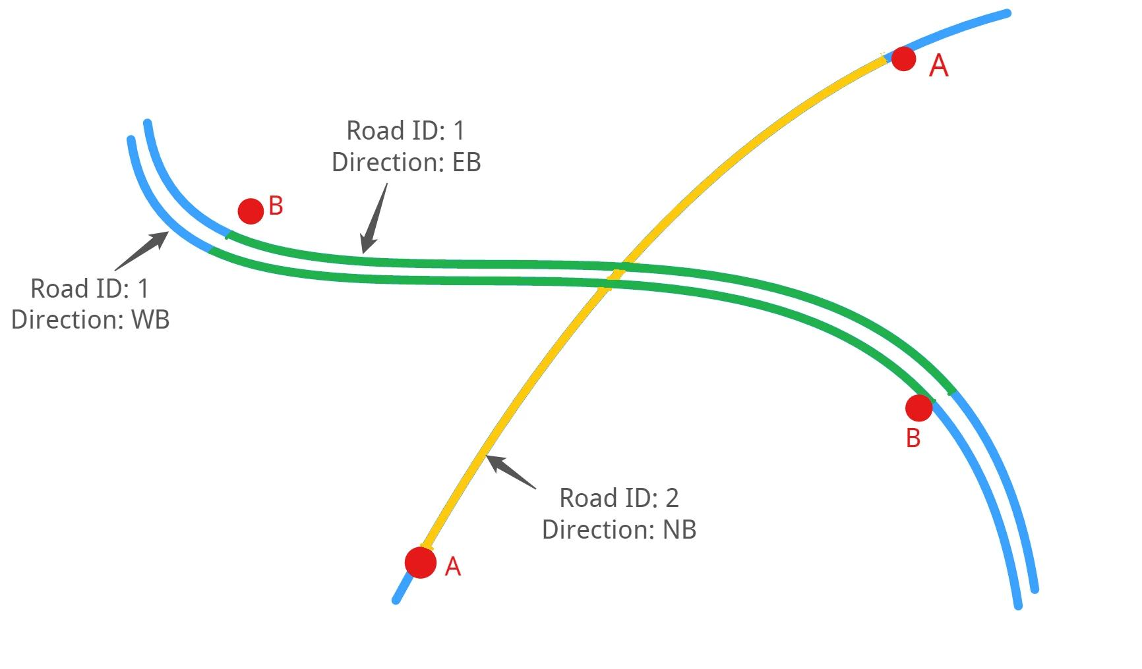

Endpoint Intersection in Computer Graphics
# Source: AI Source: Provided by: [Data Path: Persons Table -> ID Column: 1, Name_En Column: Motasem Essam] -> From: [ChatGPT] on [7/25/2026]
Computer graphics uses endpoint intersections when constructing:
- Polygons.
- Vector paths.
- Meshes.
- Shapes.
- Networks.
A polygon's vertices are essentially connection points between its edges.
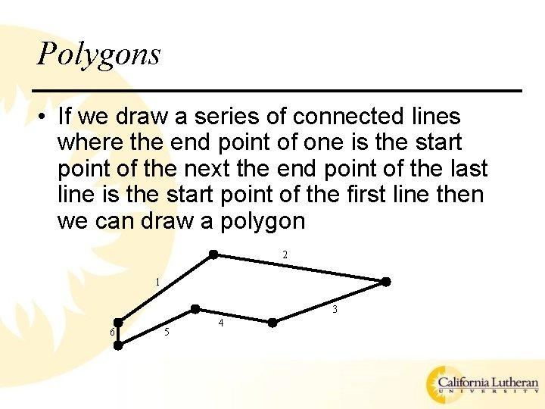
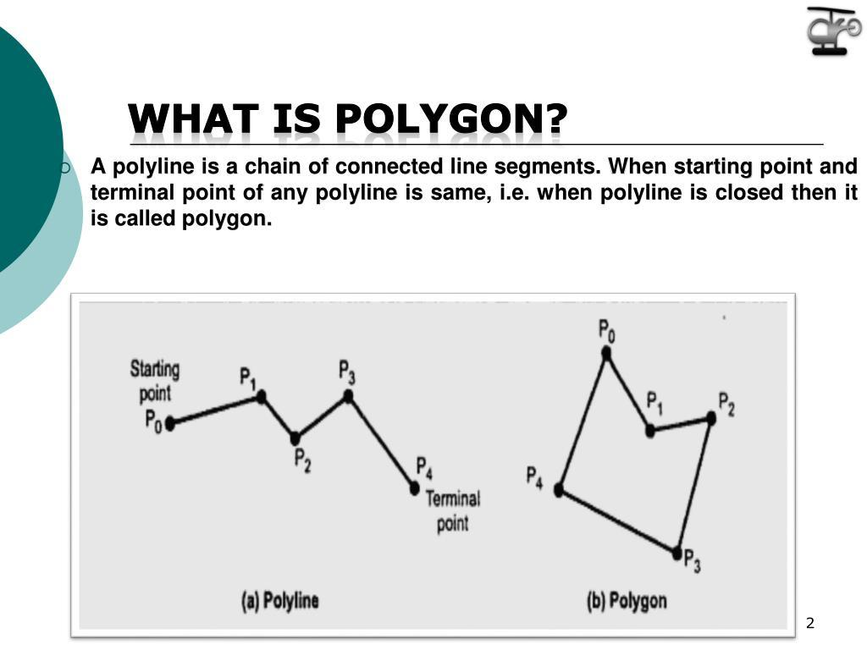

Real-World Examples
# Source: AI Source: Provided by: [Data Path: Persons Table -> ID Column: 1, Name_En Column: Motasem Essam] -> From: [ChatGPT] on [7/25/2026]
Endpoint intersections appear in:
- Corners of buildings.
- Road junctions.
- Corners of tables.
- Connections between sticks.
- Structural joints.
- Polygon vertices.
- Railway connections.
- Network nodes.
- CAD drawings.
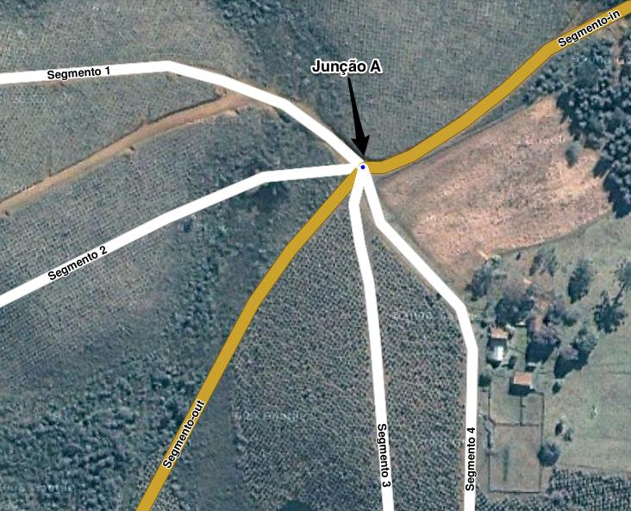
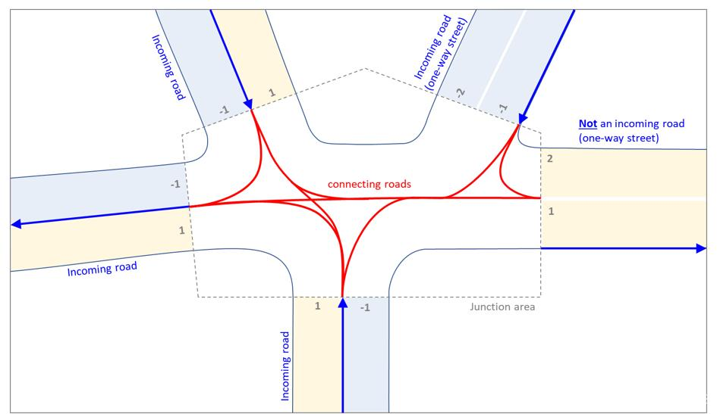
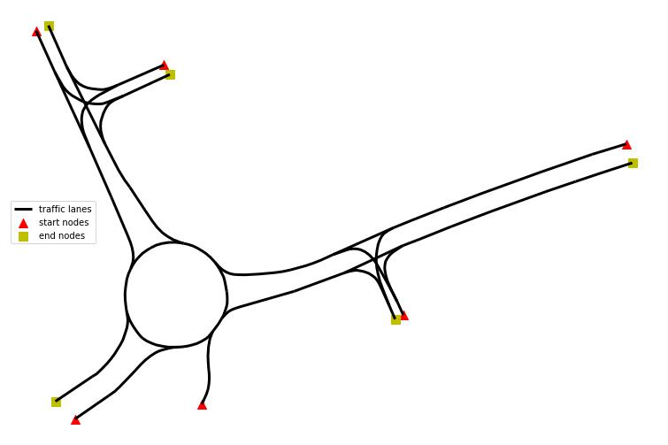
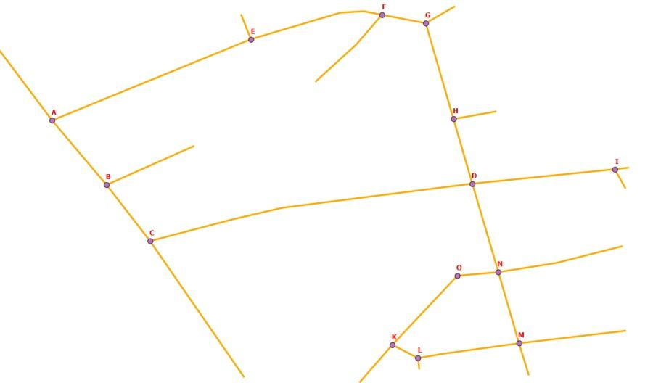
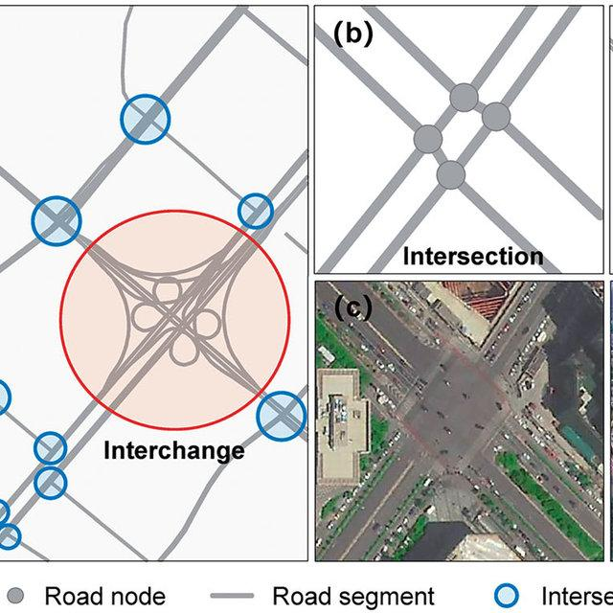

Applications
# Source: AI Source: Provided by: [Data Path: Persons Table -> ID Column: 1, Name_En Column: Motasem Essam] -> From: [ChatGPT] on [7/25/2026]
Endpoint intersection is important in:
- Plane Geometry
- Coordinate Geometry
- Polygon Theory
- Polyline Geometry
- Computational Geometry
- Architecture
- Civil Engineering
- Mechanical Engineering
- Surveying
- GIS
- CAD
- Computer Graphics
- Robotics
- Network Modeling

Advantages
# Source: AI Source: Provided by: [Data Path: Persons Table -> ID Column: 1, Name_En Column: Motasem Essam] -> From: [ChatGPT] on [7/25/2026]
Studying endpoint intersections helps to:
- Identify polygon vertices.
- Connect line segments correctly.
- Construct closed and open shapes.
- Define angles.
- Build geometric networks.
- Analyze structural connections.
- Create accurate CAD drawings.
- Model roads and paths.
- Represent complex geometric figures.

Limitations
# Source: AI Source: Provided by: [Data Path: Persons Table -> ID Column: 1, Name_En Column: Motasem Essam] -> From: [ChatGPT] on [7/25/2026]
Endpoint intersection:
- Requires the common point to be an endpoint of the involved segment(s).
- Is different from an interior intersection.
- Does not describe segments that cross only in their interiors.
- Does not describe an overlapping portion of two segments.
- Can involve more than two segments sharing the same endpoint.
- Requires careful distinction between touching and crossing.

Comparison with Related Concepts
# Source: AI Source: Provided by: [Data Path: Persons Table -> ID Column: 1, Name_En Column: Motasem Essam] -> From: [ChatGPT] on [7/25/2026]
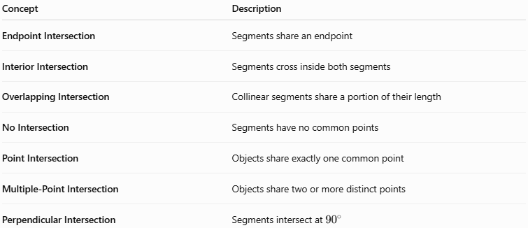
Concept | Description
Endpoint Intersection | Segments share an endpoint
Interior Intersection | Segments cross inside both segments
Overlapping Intersection | Collinear segments share a portion of their length
No Intersection | Segments have no common points
Point Intersection | Objects share exactly one common point
Multiple-Point Intersection | Objects share two or more distinct points
Perpendicular Intersection | Segments intersect at ${90}^{∘}$

Endpoint Intersection vs. Interior Intersection
# Source: AI Source: Provided by: [Data Path: Persons Table -> ID Column: 1, Name_En Column: Motasem Essam] -> From: [ChatGPT] on [7/25/2026]
The easiest way to distinguish them is by looking at the location of the common point.
Endpoint Intersection
$$\boxed{A∙B}$$
and:
$$\boxed{B∙C}$$
The common point $B$ is an endpoint.
Interior Intersection
$$\boxed{A-P-B}$$
and:
$$\boxed{C-P-D}$$
The common point $P$ lies inside both segments.

Key Points
# Source: AI Source: Provided by: [Data Path: Persons Table -> ID Column: 1, Name_En Column: Motasem Essam] -> From: [ChatGPT] on [7/25/2026]
- Endpoint Intersection occurs when two or more line segments share a common endpoint.
- If:
$$\boxed{\overline{AB}∩\overline{BC}=B}$$
then $B$ is an endpoint intersection.
- Endpoint intersections commonly form the vertices of polygons.
- Adjacent sides of polygons meet at endpoint intersections.
- Connected polylines contain endpoint intersections between consecutive segments.
- Several segments can share the same endpoint.
- Two segments can meet at an endpoint and form an angle.
- They can also be perpendicular at their shared endpoint.
- Endpoint intersection is different from an interior intersection, where the common point lies inside both segments.
- Endpoint intersections are fundamental in geometry, polygons, CAD, GIS, architecture, engineering, and computer graphics.

Conclusion
# Source: AI Source: Provided by: [Data Path: Persons Table -> ID Column: 1, Name_En Column: Motasem Essam] -> From: [ChatGPT] on [7/25/2026]
Endpoint Intersection is a type of Segment Intersection in which two or more line segments share a common endpoint. It is one of the fundamental ways that line segments connect to form vertices, polygons, polylines, angles, networks, and structural frameworks. Unlike an interior intersection, where segments cross away from their endpoints, an endpoint intersection occurs directly at the boundary of the involved segments. Endpoint intersections are therefore essential in plane geometry, coordinate geometry, polygon construction, CAD, GIS, architecture, engineering, surveying, and computer graphics.

